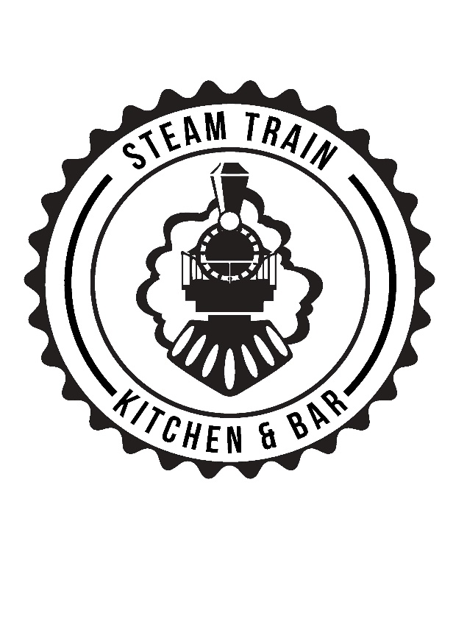

Breakfast & Brunch (until 12pm) *all day as marked*
Toast (2) V(VO) all day $5
butter/jam/vegemite/Nutella
Fruit toast V all day $4.5/8
Croissant V all day
House baked croissant with house made jam & butter $6
Granola V
with Greek yoghurt, poached pear, blueberry compote, raw local honey & coconut $13
Açaí Bowl (VO) GFO all day
blended to order with frozen banana & berries, topped with granola seasonal fruit and raw local honey $16
Bacon & egg burger GFO all day
bacon, soft fried egg, cheddar, mozzarella, spinach & chipotle relish $12
add hash brown $2
add haloumi $3
Avocado V (VO) GFO
seasoned & smashed on sourdough, feta, house made dukkah, lemon wedge, rocket & olive oil
1 piece $13
2 pieces $16
add roasted mushroom & parmesan $4
add poached egg/s $3/$5
Chilli bean & chorizo GFO VO (VO)
slow cooked chilli beans & chorizo, fried egg sharp parmesan, herbs & sourdough $18
Potato Hash V (VO) GFO
potato hash, slow roasted mushrooms, poached egg, salsa verde, kale chips on a bed of spinach & fresh herbs $17
Bacon & Pickles
sourdough, house made labneh, bacon, pickled zucchini & Spanish onion, rocket & salsa verde $16
add poached egg $3
V– Vegetarian (V) – Vegan
GF – Gluten Free O – Option available

Canuck Waffles VO
sweet potato, cheese & chive waffles, maple bacon and fried egg $18
V – swap maple bacon for haloumi
Savoury Mince GFO
slow cooked lean beef mince with diced vegetables, served with a poached egg, sourdough & garlic tomato passata $18

Eggs your way V GFO
free range eggs (fried, scrambled or poached) house made dukkah, $11
relish & butter on request
Make your own big breakfast
Eggs your way + any 3 sides $23
SIDES
bacon, chorizo, hash browns (2), mushroom, avocado, haloumi, chilli beans $4.5
free range egg/s $3/$5
broccolini & Asparagus $5.5

Doggos Breakfast
Puppacino with a side of bacon $4.5
TOASTIES made to order all day
Double cheese, onion & relish $7
Ham cheese mustard & pickle $7
Mushroom, shallots, aioli, cheese $9
Chilli bean & cheese $9
BLT $9
BURGERS (from 11am)
GF Buns available $1
Add fries to your burger for $4
Magic Mush $16
Slow roasted swiss brown, haloumi,
cos lettuce, tomato, Spanish onion,
relish & aioli V (VO)
Cheesy Boi $13
150g beef patty, Spanish onion, pickles, cos, American cheese, tomato relish, mustard
Double Cheesy Boi $18
Cheesy boi with double patty & cheese
Steamtrain Classic $16
150g beef patty, bacon, American cheese, cos, tomato, onion, beetroot relish
The Big Smoke $14
13-hour slow cooked smokey pulled pork, cos lettuce, apple slaw
Chicken BLT $16.9
Fried Chicken, bacon, tomato, cos, American cheese & aioli
Posh Spice $16
Fried chicken, cos, onion rings, apple slaw, chipotle aioli
Lean & Green $15
Grilled chicken, avocado, tomato, cos, spanish onion & aioli

Sides
Popcorn Chicken $10
Herb salted fries (VO) $6
Aioli, ketchup, mustard, BBQ $1
Haloumi fingers V $7
Onion Rings V $7
Loaded Fries- bacon, mozzarella, parmesan, mustard, ketchup &
shallots $11

We are licensed from 10am
Please ask for our drinks list

Champagne Breakfast for 2 (Saturday)
Start with 2 small coffees, then enjoy a bottle of Pete’s Pure Prosecco & OJ for mimosas, 2 small Acai bowls, 2 fresh baked croissants with house made strawberry jam & a complimentary bottle of sparkling water
$80

Saturday Drink Special!
Bottomless Mimosas from 10am-1pm with any main meal $30
Responsible service of alcohol applies

Please advise of allergies when ordering

